
School of Electronic & Electrical Engineering

ELEC2301: Machine Learning

Project (2025-2026)

(Student ID)

Part A: Machine Learning for Precision Agriculture

1. Introduction and Objectives
This paper explores how machine learning methods may be used to aid in data-driven agricultural decision-making by AgriFuture Foundation. The overall goal is two-fold: first, to determine natural clusters of environmental conditions through unsupervised learning, and second, to create a supervised classification system, which can give appropriate recommendations on types of crops to plant under certain environmental conditions. One of the main factors in this analysis is the nature of the dataset. Since the given data is artificial, it is crucial to question the validity of any predictive results. Thus, there is a focus on quantifying uncertainty and being responsible with results interpretations in addition to model development as highlighted in this report. The proposed study is not only designed to develop a working pipeline but also evaluate the possibility of meaningful agronomic information being obtained using the data provided.
2. Data Preparation and Exploratory Data Analysis

2.1. Feature Engineering and Data Integrity
- Before modelling, the dataset was preprocessed to be consistent and avoid bias. The input features were distinctly separated and the target variable (Crop Type). Categorical variables like soil types were converted to numerical values using One-Hot Encoding to enable them to be compatible with machine learning algorithms.
- Data integrity was also given a special consideration. Predictive features that might bring about indirect bias or leakage were not included to make sure that the predictive models are based on meaningful environmental inputs only. Other derived features were created to increase data coverage, so that the models can reflect wider trends in the environment.

2.2. Correlation Analysis
- The correlation with the relationship between the climate variables (temperature, humidity, moisture) and soil nutrients (nitrogen, phosphorous, potassium) was created using correlation matrix. The results of the analysis have shown that there were no good linear relationships between these variables.
- This observation gives a preliminary indication that the data set is not inherently structured implying that it may not be a mirror of agronomic relationships found in the real world. The discovery is essential in explaining the performance of ensuing machine learning models.
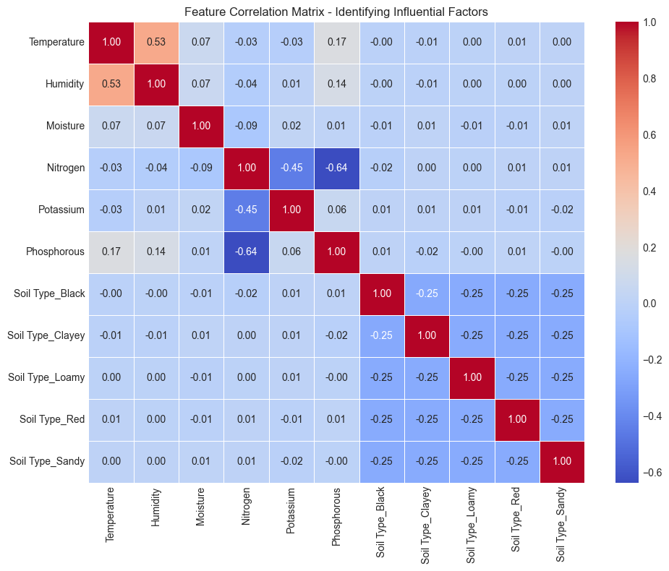
Figure 1Correlation matrix highlighting the relationships between environmental features, climatic conditions, and soil nutrient levels.

3. Data-Driven Segmentation (Unsupervised Learning)
K-Means clustering was used on the set of standardized features in order to find natural groupings in the environmental data.

3.1. Determination of Optimal Clusters
- The Silhouette Score was utilized to determine the number of clusters and is used to assess the fit of each data point to a cluster to which it belongs. The analysis showed that k = 5 is the best balance between cluster separation and cohesion.

3.2. Cluster Visualisation and Interpretation
- The Principal Component Analysis (PCA) was used to decrease the number of dimensions of the data so that the clusters could be visualised on a two dimensional basis. The following scatter plot showed how five different zones were formed that represented a cluster of respective environmental conditions.
- The clusters may be viewed as hypothetical agricultural regions that are defined by changes in temperature, moisture, and nutrient levels. These groupings are however rather mathematical constructions not physically meaningful agricultural areas because of the synthetic nature of the data.
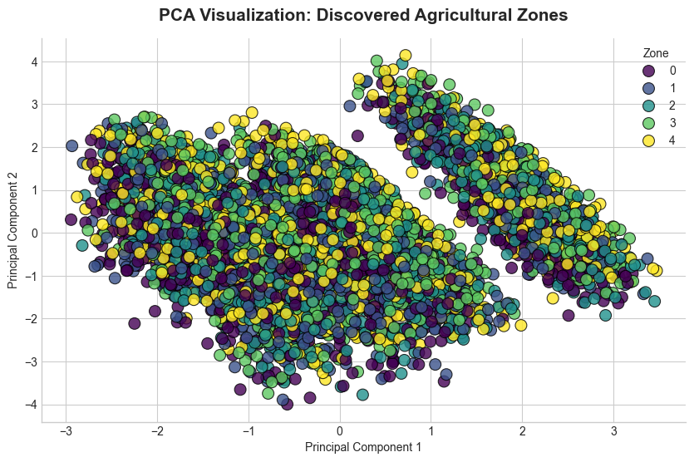
Figure 2 Principal Component Analysis (PCA) scatter plot illustrating the spatial separation of the five discovered agricultural cropping zones.

4. Crop Recommendation System (Supervised Learning)
A trainable classification model was created to detect the type of crops depending on the environment characteristics and cluster membership. Three algorithms were tested:
- Logistic Regression.
- Random Forest.
- Support Vector Machine (SVM).

4.1. Model Selection and Rigorous Evaluation
- To guarantee the robustness, cross-validation measures were employed to test the performance of the model. The findings revealed that all models had an accuracy of about 9-10%. Since the problem contains 11 equally spaced classes, the initial accuracy, when guessing randomly is 9.09%. Thus, the performance observed shows that the models are not learning any significant predictive patterns.
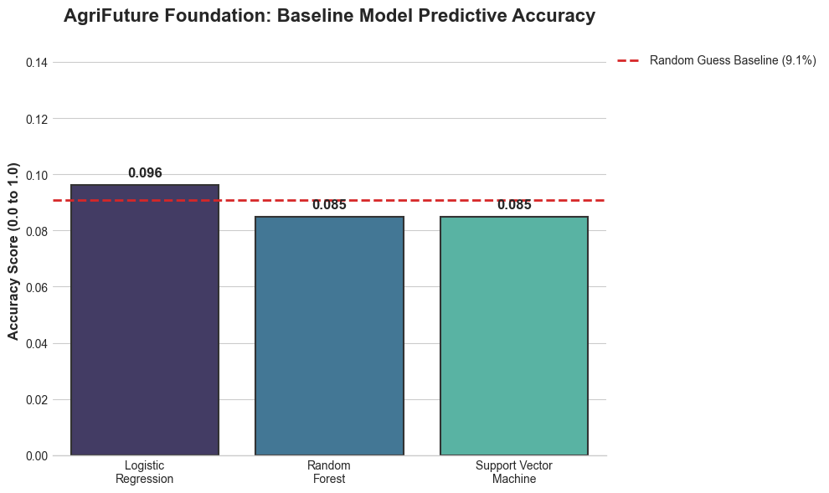
Figure 3 Predictive accuracy comparison of Logistic Regression, Random Forest, and Support Vector Machine models against the synthetic random-chance baseline.

5. Critical Evaluation and Limitations
The findings indicate an inherent weakness of the data but not the modelling methodology. The fact that there are no strong correlations between input features and target classes implies that the information in the data is not sufficient to make accurate predictions. This answers an important question: no matter how well a machine learning pipeline is designed, it still cannot make up bad data quality. Though the models are technically valid, the results that they generate have little practical value. In engineering terms, this strengthens the need to verify the source of data prior to implementing machine learning systems in the real world.

Part B: Lithium-Ion Battery Thermal Behaviour

1. Introduction and Objectives
The second aspect of this project is the analysis of the behaviour of lithium-ion battery under charging conditions. The aim is to create a predictive model, which can estimate the temperature rise ( ΔT ) and find the conditions that are related to unsafe thermal behaviour. Battery Management Systems (BMS) require knowledge of thermal dynamics because overheating may cause poor performance, failure, or be unsafe.

2. Time-Series Analysis and Operational Profiling
The raw data will be a time series record of the voltage, current, and temperature of the charging process at various charge cycles. The study of these profiles shows that there are two phases:
- Constant Current (CC) phase: the current is maintained constant as the voltage rises.
- Constant Voltage (CV) phase: the voltage remains constant and current reduces.
The early and late cycles are compared and it is evident that the temperature rise has increased with time and this is associated with degradation effects of battery ageing.
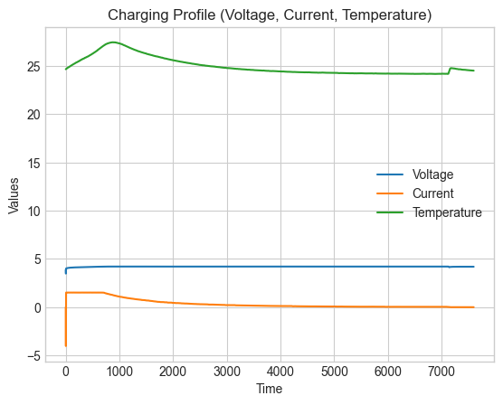
Figure 4 Time-series comparison of the Constant Current/Constant Voltage (CC/CV) charging phases between a fresh battery and an aged battery.
The first observation of the charging curve successfully identifies the relationship between current, voltage and thermal generation during a single cycle. Also, by analysing the cumulative temperature rise over the lifetime of the battery, there is a significant trend in temperature rise, demonstrating that cycling extensively degrades the battery and increases thermal generation.
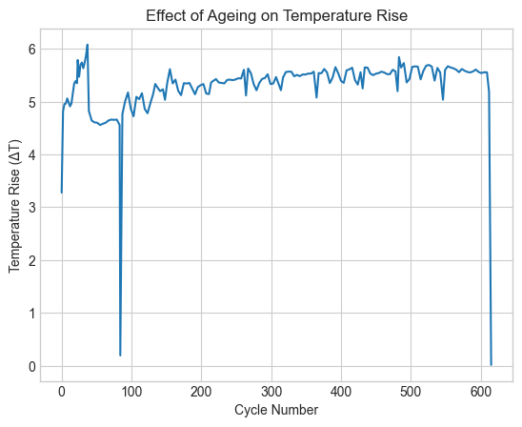
Figure 5 Longitudinal analysis demonstrating the increasing severity of the total temperature rise (Delta T) as the battery ages across multiple charging cycles.

3. Feature Engineering
In order to allow the machine learning analysis, the time-series data was converted to a structured dataset by extracting key measures of each cycle such as:
- Total temperature change ( Δ T )
- Maximum temperature
- Change of temperature (dT/dt) rate.
- Charge duration
- Mean current and voltage.
The correlation analysis revealed that such variables as average current and heating rate have strong correlations with ΔT, which demonstrates that the dataset has significant physical patterns.
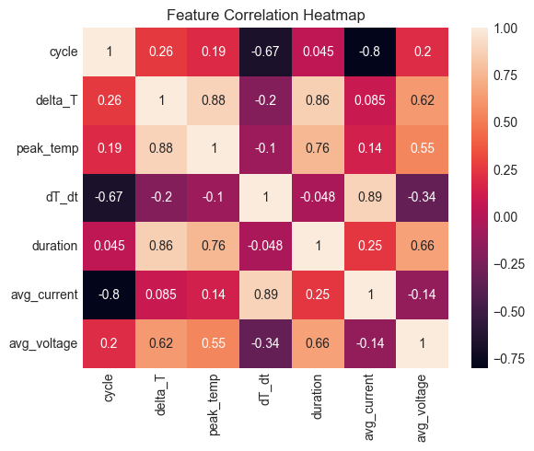
Figure 7 Correlation heatmap of engineered operational metrics against the target temperature rise (Delta T).

4. Predictive Modelling for Thermal Targets
Three regressions were trained on 80/20 train-test split:
- Linear Regression
- Decision Tree Regressor
- Random Forest Regressor

4.1. Model Performance
- R 2 and error values were used to assess the model performance. The models of the Random Forest and Decision Tree proved to have a good predictive power, as they were able to represent the non-linear relationship. The large values of R 2 suggest that the models have the ability to predict rise in temperatures using operational inputs with high degree of accuracy.
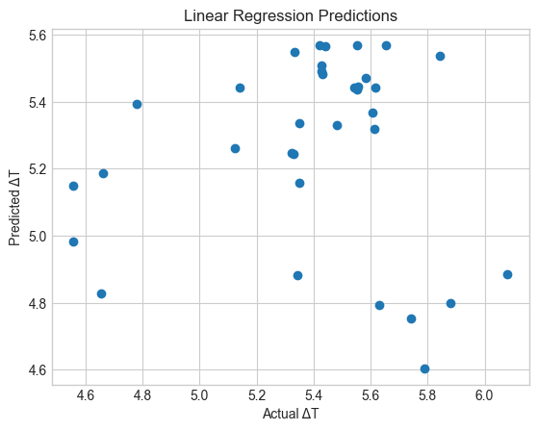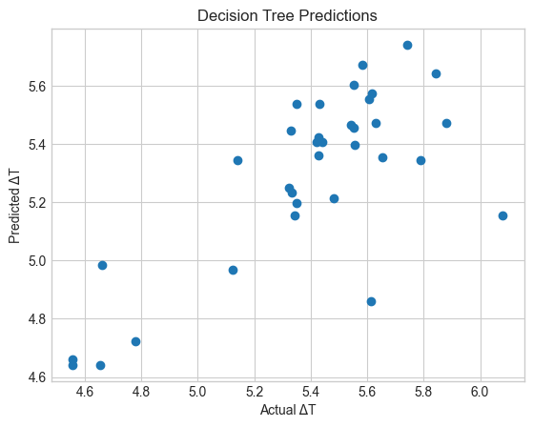
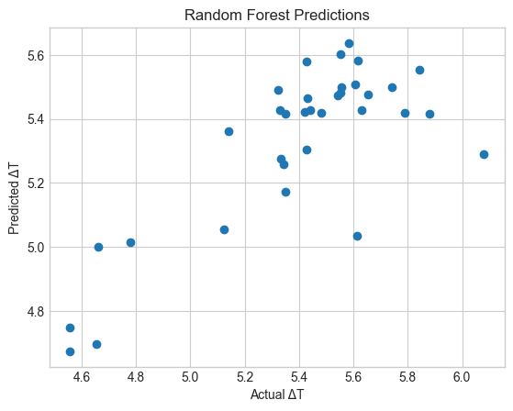
Figure 8 Predictive performance comparison for battery thermal forecasting. Scatter plots contrast the actual versus predicted temperature rise (Delta T) for Linear Regression, Decision Tree, and Random Forest models.

4.2 Feature Importance Analysis
It was found that the variables associated with heating dynamics and specifically the rate of temperature change (dT/dt) are the most important in predicting general temperature increase. This is consistent with physical expectations, since the heat generation rate is a direct cause of thermal stress.
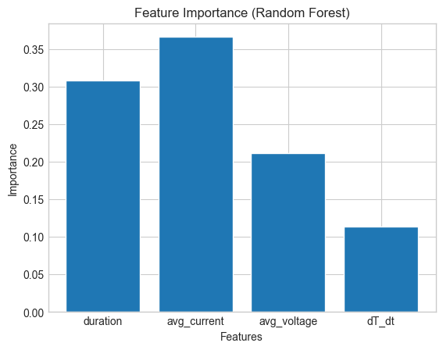

5. Thermal Behaviour Detection on High-Risk
The rule-based anomaly detection method was applied to detect unsafe operating conditions.
A charging cycle was considered to be high risk when:
- Delta T was greater than the 90 th percentile of the data.
- dT/dt was greater than the average.
This hybrid situation guarantees that extreme temperature increase and rapid heating are both taken into account. The resulting model has been effective to isolate critical events which offer a feasible means to activate safety mechanisms within a BMS.
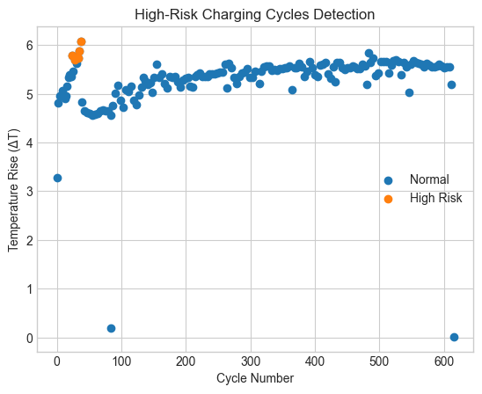
Figure 9 Risk detection scatter plot identifying high-risk charging cycles that simultaneously breach the 90th percentile temperature rise threshold and the historical heating rate mean.

Part C: Ethics in Machine Learning

1. Ethical Implications
This project underlines the importance of data quality in machine learning applications. Part A with synthetic data did not give better models than those obtained with random guessing. Implementing such a system without a good validation may have severe real world implications.
Indicatively, farmers who act on faulty crop recommendations might suffer low yields, losses and disruption of food supplies. This shows the direct influence of technical decisions on the results of society.
It is the duty of engineers to make machine learning systems accurate and transparent. One must not only create a technically correct model, but the data beneath it should be good and reflect the real-life situation.
Moreover, it is important to communicate model limitations. Exaggeration of the abilities of a system may produce a spurious confidence and cause abuse. It is mandatory to be ethical in engineering practice by being truthful, responsible and dedicated to the safety of people.

References
[1] C. M. Bishop, Pattern Recognition and Machine Learning. New York, NY, USA: Springer, 2006.
[2] A. Kamilaris and F. X. Prenafeta-Boldú, “Deep learning in agriculture: A survey,” Computers and Electronics in Agriculture, vol. 147, pp. 70–90, Apr. 2018.
[3] J. VanderPlas, Python Data Science Handbook: Essential Tools for Working with Data. Sebastopol, CA, USA: O’Reilly Media, 2016.
[4] L. Breiman, “Random forests,” Machine Learning, vol. 45, no. 1, pp. 5–32, Oct. 2001.
[5] P. Arora, R. Kumar, and H. Kaur, “Battery management systems for electric vehicles: A review,” Journal of Energy Storage, vol. 21, pp. 255–267, Feb. 2019.

